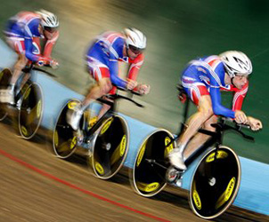

Name:……………………………………

**BTEC Level 2 Unit 1- Fitness for Sport and Exercise**

**Student Revision Guide**

Before we start – Overview

**Learning aims:**

**A:** Know about the components of fitness and the principles of training

**B:** Different fitness training methods

**C:** How to test fitness levels

Make sure you know about all three!

All three areas will be assessed in a computer based exam. There will be a mix of multiple choice and longer answer questions.

Your exam is on **Thursday 6th March**

All exam revision materials are available on Weebly at the following link:

[**http://fhspe.weebly.com/exam-revision.html**](http://fhspe.weebly.com/exam-revision.html)

Study Guide - Contents Page

Components of physical fitness 4

Components of skill related fitness 5

Heart rate 6

Principles of training 8

Training methods 9

Fitness testing 14

Learning aim A

## A2



**Learning aim A: Know about the**

**components of fitness and the**

**principles of training**

*Components of* ***PHYSICAL*** *fitness:*

|  |  |
| --- | --- |
| Component of physical fitness | Definition |
| Aerobic Endurance | It is the ability of the cardio-respiratory system to efficiently supply nutrients and oxygen to working muscles during sustained physical activity |
| Muscular Endurance | The ability of the muscular system to work efficiently, where a muscle can continue contracting over a period of time against a light to moderate fixed resistance load |
| Flexibility | Having an adequate range of motion in all joints of the body; the ability to move a joint fluidly through its complete range of movement |
| Speed | Distance divided by the time taken |
| Muscular Strength | The maximum force (in kg or N) that can be generated by a muscle or muscle group |
| Body Composition | The relative ratio of fat mass to fat-free mass (vital organs, muscle, bone) in the body |

*Components of* ***SKILL RELATED*** *fitness:*

Agility: Combination of speed and coordination which allows the body to change direction and body position at speed.

Balance: Ability to maintain a centre of mass over a base support

Coordination: The smooth flow of movement needed to perform a motor task efficiently and accurately

Power: The product of strength and speed

Reaction time: The time taken for a sports performer to respond to a stimulus and the initiation of their response.

Why fitness components are important for successful participation:

* Being able to successfully meet the physical demands of sport
* Being able to successfully meet the skill related demands of sport
* Being able to perform efficiently
* Able to adapt to different events/positions

*EXERCISE INTENSITY and how it can be assessed-*

The average persons HR is between 60-80

beats per minute (bpm)

Training can lower this and athletes can have a much lower bpm.

Heart Rate increases during exercise to allow more oxygen to the muscles

******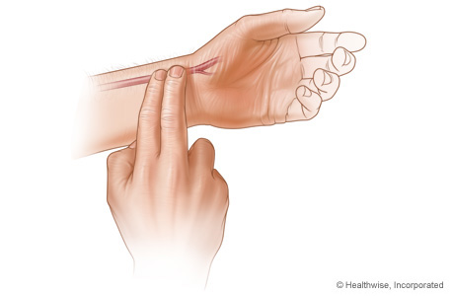***How to measure HR:***

Gently press two fingers against the pulse and using a stopwatch count the beats. You can count for 30 seconds and then double it or 10 seconds and multiply by 6.

***HEART RATE MAX (HR max):***

* This is a measure of the maximum HR your heart can beat at.
* It is calculated roughly as:

220-Age of Athlete=HR max

so if the person is 18 their HR max will be :

220-18=202 bpm

* This can then be used to calculate training zones e.g. 70% of HR max:

202/100= 2.02 x 70 = 141.4

* You would then exercise at 141 bpm, checking your pulse every few minutes with a HR monitor

***TARGET HEART RATE:***

To improve cardiovascular fitness (endurance) you need to work between 60-85% of your max HR.

So if your max HR is 200bpm you should be working between 120 and 170bpm.

***Rate of Perceived Exertion (RPE)-***

This is an estimate to find out how hard an athlete is working on a scale of 6-20.

A Footballer may report an RPE of around 14, whereas an ironman triathlete may record an RPE of 19

RPE x 10 = HR (bpm)

*Basic principles of training (FITT):*

**Intensity**: how hard they will train

**Frequency**: the number of sessions

FITT

**Time:** how long will they train for

**Type:** what training method

*Additional principles of training:*

* **Progressive overload**: in order to progress, training needs to be demanding enough to cause the body to adapt, improving performance.
* **Specificity**: training should be specific to the individuals sport
* **Individual differences/needs**: the programme should be designed to meet individual training goals and needs
* **Adaptation**: how the body reacts to training loads by increasing its ability to cope with those loads
* **Reversibility**: when training stops training effects are reversed.
* **Variation**: it is important to vary the training regime to avoid boredom and maintain enjoyment

Learning aim B

**Learning aim B: Explore different fitness training methods**

Directive Terms

Before undertaking a training method session you must consider the following:

1. Correct and safe use of equipment
2. Correct and safe technique
3. Warm up and cool down
4. Use the FITT for each fitness training method
5. Training must be appropriate to the physical/skill related component of fitness which needs to be developed

[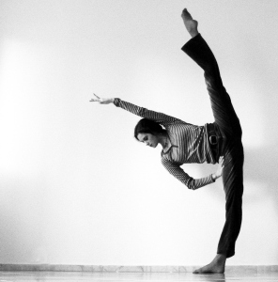](http://mcsophie.files.wordpress.com/2012/05/flexibility2.jpg)

***Flexibility training methods:***

**Flexibility definition** - Having an adequate range of motion

in all joints of the body; the ability to move a joint fluidly

through its complete range of movement

**Three** different types of stretching to improve flexibility:

[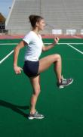](http://livelovesweat.files.wordpress.com/2011/12/dyn.jpg) **STATIC DNYNAMIC/BALLISTIC PNF**

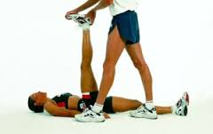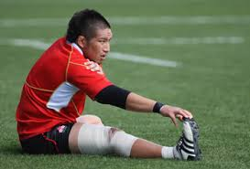

**Static stretching:**

This is when an individual holds the position, keeping the body still for the duration of the stretch (5-10 seconds).

Static stretching is the most often used form of stretching as it is very straightforward and safe. There are two different types of static stretch:

* *Static Active* – where the athlete performs the stretch independently by applying internal force to stretch and lengthen the muscle.
* *Static Passive* (assisted stretching) – requires the help of another person or object. The assisting person or object applies external force causing the muscle to stretch.

**Dynamic/ballistic stretching:**

Involves fast, jerky movements involving the whole range of the joint’s motion.

Usually through swinging, bobbing or bouncing.

**Proprioceptive Neuromuscular Facilitation (PNF):**

Performed with someone or something to create a resistance.

Stretch to max hold it there (6-10 seconds) relax repeat

***Strength, muscular endurance and power training methods:***

**Three** types of training to improve strength, muscular endurance and power-

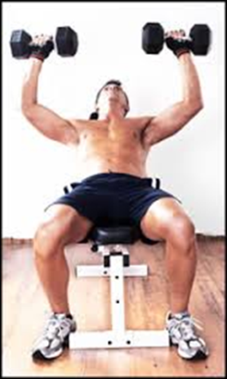CIRCUIT TRAINING FREE WEIGHTS PLYOMETRICS

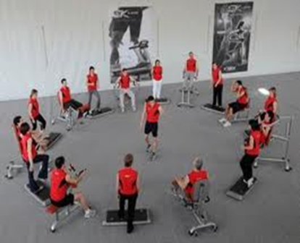[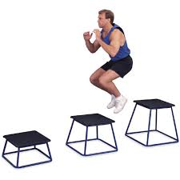](http://www.google.co.uk/url?sa=i&rct=j&q=PLYOMETRICS&source=images&cd=&cad=rja&docid=XIB0s-t2qXhrPM&tbnid=11Sn2Oa_bDT7BM:&ved=&url=http://rebuildingchampions.com/plyometrics-tips-beginners.html&ei=pXOgUu31DoWe7AaV9IDIAw&psig=AFQjCNGgdBEmC94qOHZMTsjIed-DkC8lvQ&ust=1386333477555128)

**Circuit training:**

* This involves a number of Stations
* The athletes work around these stations
* Different exercises work different muscle groups
* Whole Body Workout

**Free weights:**

* Use of barbells or dumb-bells
* Training for strength- low reps and high loads
* Training for endurance- high reps and low loads

**Plyometrics:**

* Plyometrics helps to develop specific power and strength.
* Often used by sprinters and hurdlers who need to jump and run quickly.
* Games Players such as basketballers etc also find it useful
* Plyometric exercises require the athlete to generate maximal force as the muscle lengthens before an immediate maximal force as the muscle shortens.

***Aerobic endurance training methods:***

**Four** methods of training to improve aerobic endurance:

CONTINUOUS FARTLEK INTERVAL TRAINING CIRCUIT

[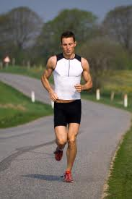](http://www.google.co.uk/url?sa=i&rct=j&q=CONTINUOUS+TRAINING&source=images&cd=&cad=rja&docid=RjzC-5vQkm2MeM&tbnid=yyxtNYnxLkUArM:&ved=&url=http://edaviesbtecsport.blogspot.com/2010/09/continuous-training.html&ei=Gn-gUti9JufH7AafwIDYAg&psig=AFQjCNGxSCKt8pdJ4xen_2dPKp_0SvypwA&ust=1386336410898584)[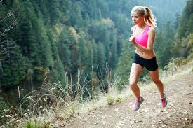](http://www.google.co.uk/url?sa=i&rct=j&q=FARTLEK%20TRAINING&source=images&cd=&cad=rja&docid=Dmyv2diQYB0YOM&tbnid=XhTIVidkQr7ymM:&ved=0CAUQjRw&url=http://www.newintervaltraining.com/fartlek-training.php&ei=WH-gUpKLMueg7AbdhYCYAw&psig=AFQjCNErv9CjmaZULvQDPvf_4dKTpX_QTg&ust=1386336452206720)

[](http://www.google.co.uk/url?sa=i&rct=j&q=CONTINUOUS+TRAINING&source=images&cd=&cad=rja&docid=RjzC-5vQkm2MeM&tbnid=yyxtNYnxLkUArM:&ved=&url=http://edaviesbtecsport.blogspot.com/2010/09/continuous-training.html&ei=Gn-gUti9JufH7AafwIDYAg&psig=AFQjCNGxSCKt8pdJ4xen_2dPKp_0SvypwA&ust=1386336410898584)

REST

[](http://www.google.co.uk/url?sa=i&rct=j&q=CONTINUOUS+TRAINING&source=images&cd=&cad=rja&docid=RjzC-5vQkm2MeM&tbnid=yyxtNYnxLkUArM:&ved=&url=http://edaviesbtecsport.blogspot.com/2010/09/continuous-training.html&ei=Gn-gUti9JufH7AafwIDYAg&psig=AFQjCNGxSCKt8pdJ4xen_2dPKp_0SvypwA&ust=1386336410898584)

**Continuous:**

* Involves exercising at a steady pace at moderate intensity for a minimum of 30mins with no rest.
* A person who goes running for 45 mins without stopping is performing continuous training.
* Continuous training is effective but can be boring

**Fartlek:**

* Fartlek is Swedish for ‘Speed Play’
* It is a form of continuous training where the intensity of training is varied.
* You can vary the speed, terrain or load you are training at. E.g. Jog –Run-Sprint
* Fartlek training is more interesting than continuous training

**Interval training:**

* Athletes perform a period of work then a period of rest and recovery
* The work period can last for various lengths of time, usually between 30secs and 5 minutes
* The rest period can be complete rest, walking or jogging
* Athletes should work at 60% VO2max to develop aerobic endurance
* Rest periods should steadily be decreased

**Circuit training:**

* The circuit should include exercises that push the body to work in the aerobic fitness zone
* As with strength the exercises should be ordered correctly in order to avoid too much fatigue.
* Intensity can be varied by adding stations, length of time working, and rest periods along with the number of times a circuit is performed

***Speed training methods:***

Three methods of training to improve speed:

1. Hollow sprints- a series of sprints separated by a ‘hollow’ period of jogging or walking
2. Acceleration sprints- Pace is gradually increased from a standing or rolling start to jogging, then to striding and then to a max sprint.
3. Interval training- Work period followed by a rest/recovery period. Performed at high intensity, close to maximum.

Learning aim C

**Learning aim C: Investigate fitness testing to determine fitness levels**

Fitness test methods for components of fitness:

|  |  |
| --- | --- |
| Component of fitness | Test |
| Flexibility | Sit and reach test |
| Strength | Grip dynamometer |
| Aerobic endurance | Multi-stage fitness test (bleep test) |
| Speed | 35m sprint |
| Speed and agility | Illinois agility test |
| Muscular endurance | One min press up, one min sit up |
| Body composition | BMI, skinfold test |

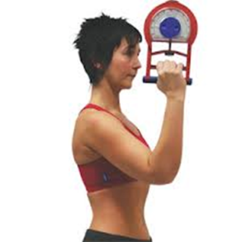

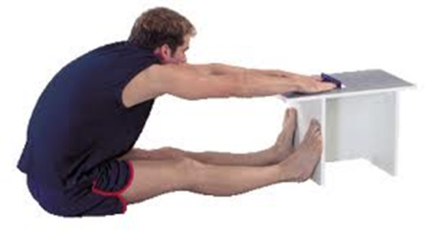

Sit and reach Grip dynamometer

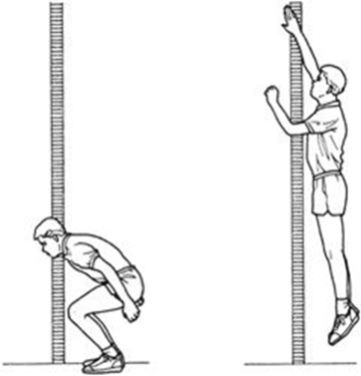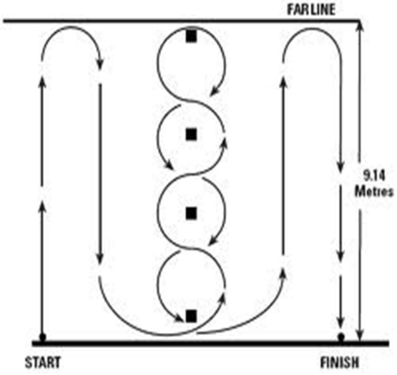

Illinois agility Vertical jump test

*The importance of fitness testing to coaches and athletes*

* Gives coach/performer baseline date for monitoring/improving performance
* Training sessions can be based around results and data
* Results can give the performer an aim/goal

1. Tell them what they will be doing
2. Check if they are ok to take part
3. Check they understand what they will be doing
4. Check any equipment is safe and correctly set up

What should you do before you test?

|  |  |
| --- | --- |
| **+ ADVANTAGES +** | **-DISADVANTAGES -** |
| Some are simple, cheap and easy to perform | Specialist equipment, training or space needed |
| Some can be repeated and the results can be looked on as reliable | Some tests may be difficult to repeat, easy to cheat at etc so results may not be reliable |
| Some are very good at measuring specific things | Some are not that good at measuring what they are supposed to measure |

**Interpreting fitness test results:**

How do the results compare to national averages, to their team mates/peers?

[](http://www.google.co.uk/url?sa=i&rct=j&q=question%20mark&source=images&cd=&cad=rja&docid=8Y48EUl_aUnsqM&tbnid=YYfg_RPwQBzTlM:&ved=0CAUQjRw&url=http://www.hdwallpapersinn.com/question-mark-pictures.html&ei=m4ugUtq0PNK7hAfr14HoBQ&psig=AFQjCNEYmwh9Akis9jX1uqeSiUAlg_WT3g&ust=1386339607749492)What does their result tell you?

Can you suggest methods of how to help them improve?